THE ISLAMIA UNIVERIESTY OF BAHAWALPUR
DEPARTMENT OF INFORMATION TECHNOLOGY


SOFTWARE DESIGN DOCUMENTATION
(SDD DOCUMENT)
For
PROJECT TITLE
“AI based Tajweed learning platform”
Version 1.0
By
Student Name:
Amna Azam(F22BINFT1E02069)
Session Fall 2022-2026
Supervised By:
Sir Zaman

Revision History

Date | Description | Author | Comments
 | SDD | Amna Azam | First Revision

Document Approval

The following Software Requirement Specifications has been accepted and approved by the following:
Signature | Printed Name | Title | Date
 | Sir Zaman | Supervisor of the project

Table of Contents

1.Introduction…………………………………………………………………………..1
1.1 Purpose……………………………………………………………………………1
1.2 Scope………………………………………………………………………………1
1.2.1 Modules……………………………………………………………………….2
1.2.2 Advantages……………………………………………………………………2
1.2.3 Disadvantages…………………………………………………………………3
1.3 Overview…………………………………………………………………………..3
1.3.1 Reference Material………………………………………………………………3
2.System Overview……………………………………………………………4
2.1 Functionality……………………………………………………………….4
3.System Architecture………………………………………………………..5
3.1 Architectural Design……………………………………………………….5
3.2 Block Diagram……………………………………………………………..6
3.3 Decomposition Description………………………………………………...6
3.2.1 Data Flow Diagrams (DFD)……………………………………………...6
Level-0 DFD – Figure 3.3……………………………………………………7
Level-1 DFD – Figure 3.4……………………………………………………8
Level-2 DFD – Figure 3.5……………………………………………………9
3.2.2 Use Case Diagrams
Admin Use Case – Figure 3.7……………………………………………….10
User Use Case – Figure 3.8………………………………………………….10
3.2.3 Activity Diagrams………………………………………………………..11
Admin Login Activity – Figure 3.9………………………………………….12
User Learning Activity – Figure 3.10………………………………………..13
4.Data Design………………………………………………………………….14
4.1 Data Description……………………………………………………………14
4.2 ER Diagram…………………………………………………………………16
5.Human Interface Design…………………………………………………….17
5.1 Overview of User Interface…………………………………………………17
Login Page……………………………………………………………………17
Lesson Page…………………………………………………………………..18
Admin Panel………………………………………………………………….19
6.Requirements Matrix………………………………………………………..19
7.Appendices……………………………………………………………………20

- Introduction
This document describes how the functional and non-functional requirements defined in the Software Requirements Specification are implemented in the system design. In this document, both the high-level and low-level system specifications are explained in detail.
The Software Design Document (SDD) describes the design objectives and goals of the system, provides an overview of the system architecture, and explains the data design of the system. It also describes the user interface and its operations. The high-level system design is divided into low-level design specifications for each component of the system, including software modules, external interfaces, and internal communication.
This project, the AI-Based Online Quran Tajweed Learning and Practice Platform, is very useful for learners who want to improve their Quran recitation according to proper Tajweed rules. It saves time that would otherwise be required to attend physical classes and allows users to learn and practice from anywhere. The system helps learners by providing correct recitation audio and AI-based pronunciation feedback. The effective use of this platform enables learners to identify pronunciation mistakes, improve accuracy, and achieve better learning results in less time.
This document proposes all the features and procedures required to develop the system. The project aims to create an interactive online Tajweed learning platform where users can learn Tajweed rules, practice Quran recitation, and receive instant feedback through an online application.
1.1 Purpose
The main purpose of this project, AI-Based Online Quran Tajweed Learning and Practice Platform, is to cooperate between the data stored in the system database and the online Tajweed learning application in order to provide learning services in an easy and efficient manner. The system is designed to manage Tajweed lessons, Quran recitation audio, and user practice activities through an online platform.
The other purpose of this project is to create a strong and secure database system that allows access only to authorized users. This system ensures secure handling of user information and prevents any unauthorized access or misuse of data while providing smooth interaction between the user, the learning modules, and the AI-based feedback system.
1.2 Scope
The Software Design Document (SDD) describes the detailed structure of all system components, their events, and the implementation details required to satisfy the requirements specified in the Software Requirements Specification (SRS).The purpose of the AI-Based Online Quran Tajweed Learning and Practice Platform is to provide an online system that helps users learn and practice Quran recitation according to Tajweed rules. The system allows users to register, log in, access Tajweed lessons, listen to correct recitation audio, and practice their pronunciation. The system also provides AI-based feedback to help users identify and correct their recitation mistakes.
This system allows the administrator to manage users, Tajweed lessons, audio content, and system data. The user can access the system at any time through the internet. To use the system, the user must first log in. Users are only allowed to view and manage their own learning records, while administrative control is restricted to the admin only.
1.2.1 Modules
Here we discuss about the modules of the “AI based Online Tajweed learning website”

Admin Login:
This system is under the supervision of the admin who manages the overall system. The admin is responsible for managing users, Tajweed lessons, audio content, and system data.
User Login:
The user must log in to access the system. After login, the user can use all learning and practice features provided by the system.
Tajweed Lessons Module:
This module allows users to learn different Tajweed rules with explanations and examples.
Audio Recitation Module:
This module provides correct Quran recitation audio to help users understand proper pronunciation.
Pronunciation Practice Module (AI-Based):
In this module, the user can record their recitation. The system analyzes the recitation using AI techniques and provides feedback on pronunciation.
Progress Tracking Module:
This module allows users to view their learning progress and practice history.
Feedback Module:
This module allows users to give feedback about the system and their learning experience.
1.2.2 Adavantages
• Users can learn Quran Tajweed at any time.
• This system saves time for learners.
• Users can listen to correct Quran recitation.
• Users can practice pronunciation easily.
• The system provides AI-based feedback.
• Users can view their learning progress.
1.2.3 Disadvantages
• Users need a stable connection for AI features.
• Possible bugs or errors in speech recognition.
• Best experience may need a microphone and good audio quality.
• Some users may take time to get used to the interface.

1.3 Overview
This document presents the design of the AI-based Quran Tajweed learning website. It covers the system architecture, software components, user interface, and database design. The design focuses on providing interactive Tajweed learning with real-time pronunciation feedback, audio practice, and progress tracking.

1.3.1 Reference Material

. System Analysis and Design

. Applying UML and Patterns

- System Overview
This project stores all user and lesson data in a database. Different users have different permissions to access the application. Each user has a unique login ID. In case of data loss, users have the option to recover their data. Users cannot modify lesson content or other users’ records; any changes require administrator approval. Only the admin has full access to manage system data and make changes. The system ensures secure, organized, and controlled access for both learners and administrators.

  - Functionality
• Allow users and admin to log in and log out of the system.
• Allow the admin to manage their profile.
• Allow users to view lessons and practice exercises.
• Allow the admin to add, update, or delete lessons and exercises.
• Allow users to submit feedback on lessons or exercises.
• Allow the admin to view user progress and feedback.
• Allow the admin to track overall lesson engagement.
• Allow users to track their own learning progress and pronunciation history.

- System Architecture
The purpose of system architecture is to define a complete solution using principles and components that are logically related and consistent. The architecture ensures that the system meets the requirements of the project, including functional, operational, and user needs, and is implementable using appropriate technologies such as software, web services, and database management systems.
  - Architectural Design
The AI-Based Quran Tajweed Learning Website follows a 3-Tier Web Architecture, which divides the system into three layers:
- Client Tier (Presentation Layer) – The web interface where users access lessons, practice exercises, audio playback, and receive real-time pronunciation feedback.
- Application Tier (Business Logic Layer) – Processes user requests, applies AI-based pronunciation analysis, manages lesson logic, and handles user progress tracking.
- Database Tier (Data Layer) – Stores user information, lesson content, audio recordings, practice results, and feedback securely.
This 3-tier architecture separates the presentation, business logic, and data storage, making the system scalable, maintainable, and easy to update. It ensures smooth interaction between users and the system while maintaining data integrity and performance.
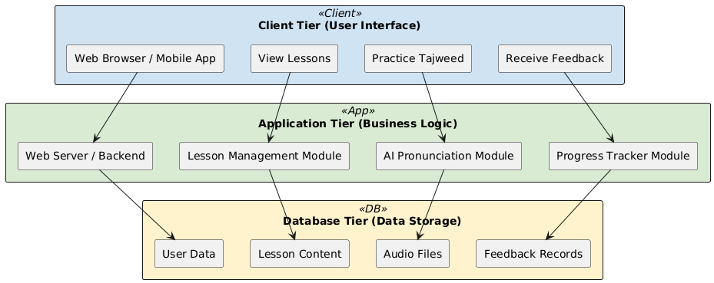
Figure 3.1(Architectural Design)

Block Diagram-1
Here we describe another block diagram for deeply understanding about the system. Block
diagrams are heavily used in engineering in hardware design, electronic design, software
design, and process flow diagrams.

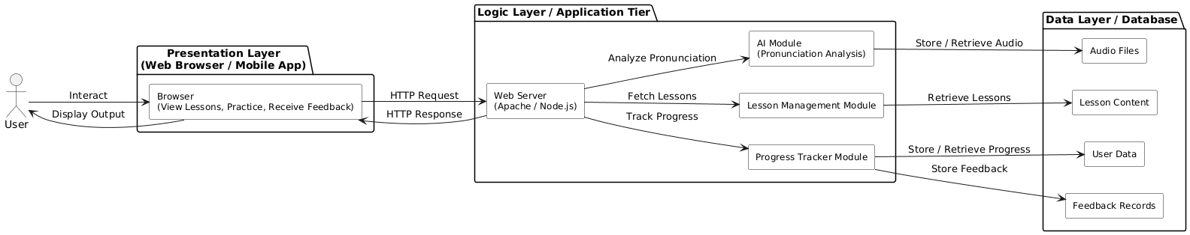
Figure 3.2(Block Diagram-1)

In this diagram, the user accesses the system via a web browser. The user’s requests (such as selecting a lesson or practicing Tajweed) are converted into the system’s understandable format, such as HTML/CSS/JS, and sent to the Application Tier. The application processes the request, interacts with the AI module, lesson management module, and database, and then returns the processed information or feedback to the user through the browser.
  - Decomposition Description
Firstly, the design is decomposed by grouping data and functions into cohesive modules. The
module decomposition identifies each of the modules and briefly outlines their purpose, type,
functions, and list of sub modules constituting this module.
    - Data Flow Diagrams
DFD (Data flow diagram) is a starting point of the design phase in the requirement
specification. Data flow diagram can be consisting of many bubbles that joined lines. In DFD
the bubbles can represent the data transformation and the lines can represent the data flow in
this system. A data flow diagram is a graphical representation of the data flow through the information system. Data flow diagram can be also used for visualization in data processing. A DFD is significant technique for the constructing and analyzing information process.
Level-0
The DFD is the graphically system’s data description and how to be process transform the data is called data Flow diagram (DFD). Here we draw a figure level-0 to explain the flow of data in the system we start from level-0 to briefly explain all the parts of the system 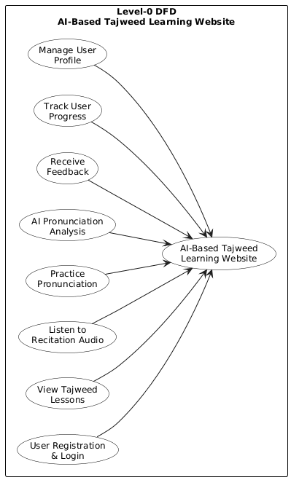Figure 3.3(level-0 Figure 3.3(level-0 DFD)
Level-1:
The DFD is the graphically system’s data description and how to be process transform the data
is called data Flow diagram (DFD). Here we draw a figure level-1 to explain the flow of data
in the system we start from level-1 to briefly explain all the parts of the system. In the previous
figure we just describe the main functions of the system and here we describe more about these
functions.
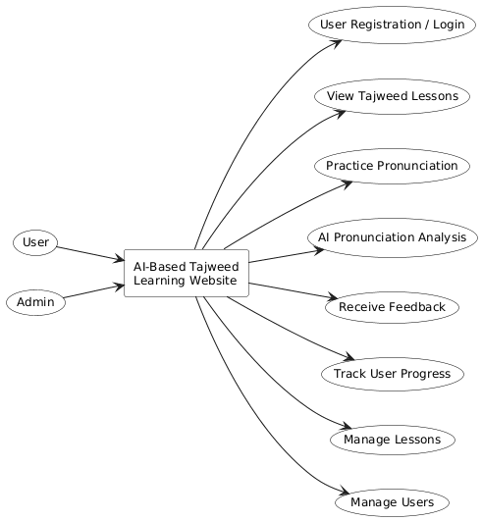

Figure 3.4(Level-1 DFD)

Level-2:
Here we draw a brief and explained data flow diagram in which we briefly describe all the functions and the flow of data.
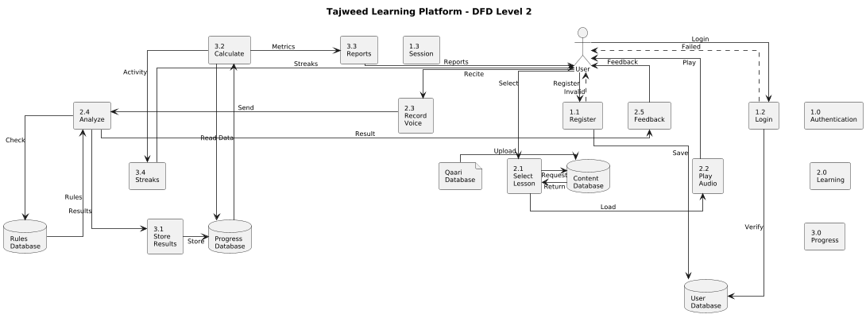
Figure 3.5(Level-2 DFD)

Use Case Diagram Of Admin:
Here we draw a use case of admin to know which are the operation admin can done. Admin
can access the following functions that are given below in the figure.

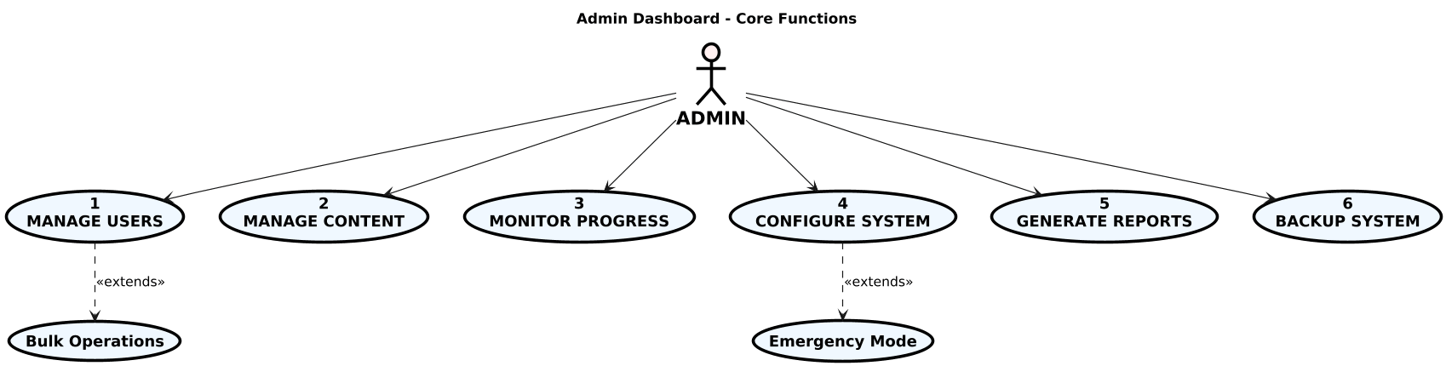
Figure3.7(Use Case of Admin)

Use Case Diagram Of User/Student:
Here we draw a use case of user/student to know which are the operation student can done. User can access the following functions that are given below in the figure.

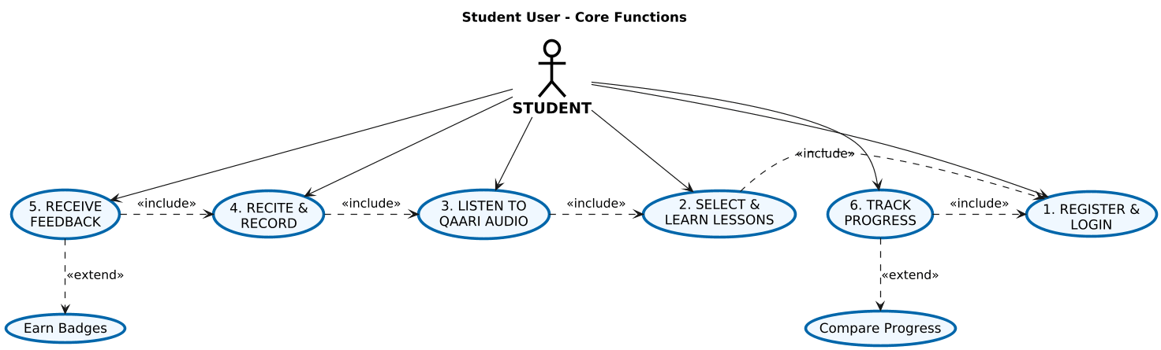
Figure3.8(Use case of User)

3.2.2Activity Diagrams
An activity diagram visually presents a series of actions or flow of control in a system similar to a flowchart or a data flow diagram. Activity diagrams are often used in business process modeling. They can also describe the steps in a use case diagram. Activities modeled can be sequential and concurrent. In both cases an activity diagram will have a beginning (an initial state) and an end (a final state). The basic purposes of activity diagrams is similar to other four diagrams. It captures the dynamic behavior of the system. Other four diagrams are used to show the message flow from one object to another but activity diagram is used to show message flow from one activity to another. Activity is a particular operation of the system. Activity diagrams are not only used for visualizing the dynamic nature of a system, but they are also used to construct the executable system by using forward and reverse engineering techniques. The only missing thing in the activity diagram is the message part.
Admin Login Activity Diagram
Here we draw an activity diagram to show the activity of the admin to hoe the admin can login to the system and what are the operations have to done for the login of admin in the system AI based Tajweed learning system.
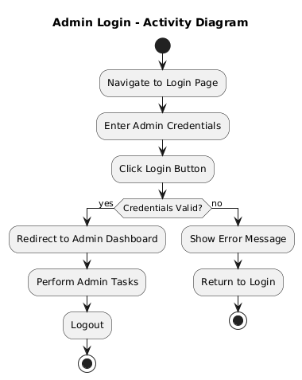. Figure 3.9(Admin activity)

User learning activity diagram
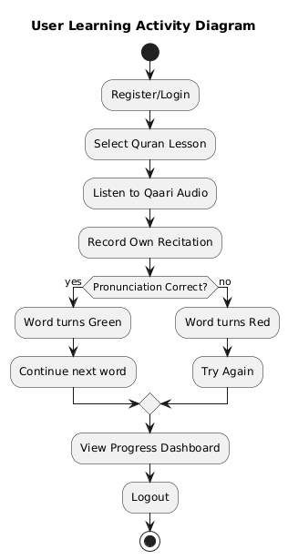
Figure 3.10(User learning Activity diagram)

4.Data Design
Database design is the organization of data according to a database model. The designer determines what data must be stored and how the data elements interrelate. With this information, they can begin to fit the data to the database model. Database management system manages the data accordingly. The overall goal of database design theory is to capture as much of our model's structure as possible. Particularly constraints in the database schema itself. Doing so allows the database engine to enforce those constraints automatically and simplifies the application logic built on top of it. Database design defines the database structure used for planning, storing, and managing information. Accuracy in data can only be accomplished if a database is designed to store only valuable and necessary information. A well-designed database is imperative in guaranteeing information consistency, eliminating redundant data, efficiently executing queries, and improving the performance of the database. Meticulously designing a database saves you from wasting time and getting frustrated during the database development phase. A good database design also allows you to easily access and retrieve data whenever needed. The reliability of data depends on the table structure; whereas creating primary and unique keys guarantees uniformity in the stored information. Data replication can be avoided by forming a table of probable values and using a key to denote the value. So, whenever the value changes, the alteration happens only once in the main table.

4.1 Data description
The Database of Online AI based Tajweed learning platform will store the information about following entities:

A. User/Student Entity:
The primary learner who uses the platform to improve Tajweed skills.
Attributes:
User ID - Unique identifier for each user
Full Name - User's complete name
Email Address - Primary contact and login identifier
Phone Number - Optional contact information
Username - Unique login name (can be same as email)
Password Hash - Securely encrypted password
Profile Picture - Optional user profile image
Account Created Date - Registration timestamp
Last Login Date - Most recent access time
User Role - Student or Administrator designation
Account Status - Active, Inactive, or Suspended

B. Quran Lessons Entity:
The structured learning content containing Quranic verses with expert recordings.
Attributes:
Lesson ID - Unique identifier for each lesson
Surah Number - Chapter number in the Quran
Ayah Number - Verse number within the Surah
Ayah Text - Complete Arabic text of the verse

Difficulty Level - Beginner, Intermediate, or Advanced

Audio File URL - Link to Qaari expert recording

Audio Duration - Length of recording in seconds

Created By - Admin who uploaded the content

Creation Date - When the lesson was added to system

Tajweed Rules - Associated pronunciation rules for the verse

C. Practice Sessions Entity:
Individual learning attempts where users practice recitation.
Attributes:
Session ID - Unique identifier for each practice session
User ID - Reference to the practicing student
Lesson ID - Reference to the Quran lesson being practiced
Start Time - When the session began
End Time - When the session completed
Total Score - Overall accuracy percentage
Session Status - Completed, In Progress, or Abandoned
Words Correct - Number of correctly pronounced words
Words Incorrect - Number of mispronounced words
Time Spent - Total practice duration in seconds

ER Diagram
An Entity Relationship (ER) Diagram is a type of flowchart that illustrates how “entities” such as people, objects or concepts relate to each other within a system. ER Diagrams are most often used to design or debug relational databases in the fields of software engineering, business information systems, education and research.

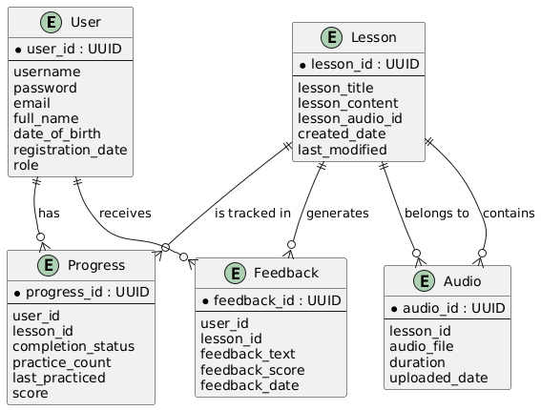

5.Human Interface Design
Human Interface Design (HID) is the discipline that focuses on how humans interact with software systems and digital objects. Its goal is to create an interface that is intuitive, efficient, and visually pleasing, while ensuring that the user can achieve their objectives comfortably and effectively. A well-designed human interface improves usability, reduces errors, and enhances the overall user experience.
Human interface design is essential because it determines how users interact with the system, how easily they can navigate the application, and how efficiently they can perform tasks such as learning and practicing Tajweed.

5.1 Overview of User Interface
The system’s user interface (UI) must satisfy the functional requirements to ensure proper operation of the website. Users will interact with the website to:

Login page
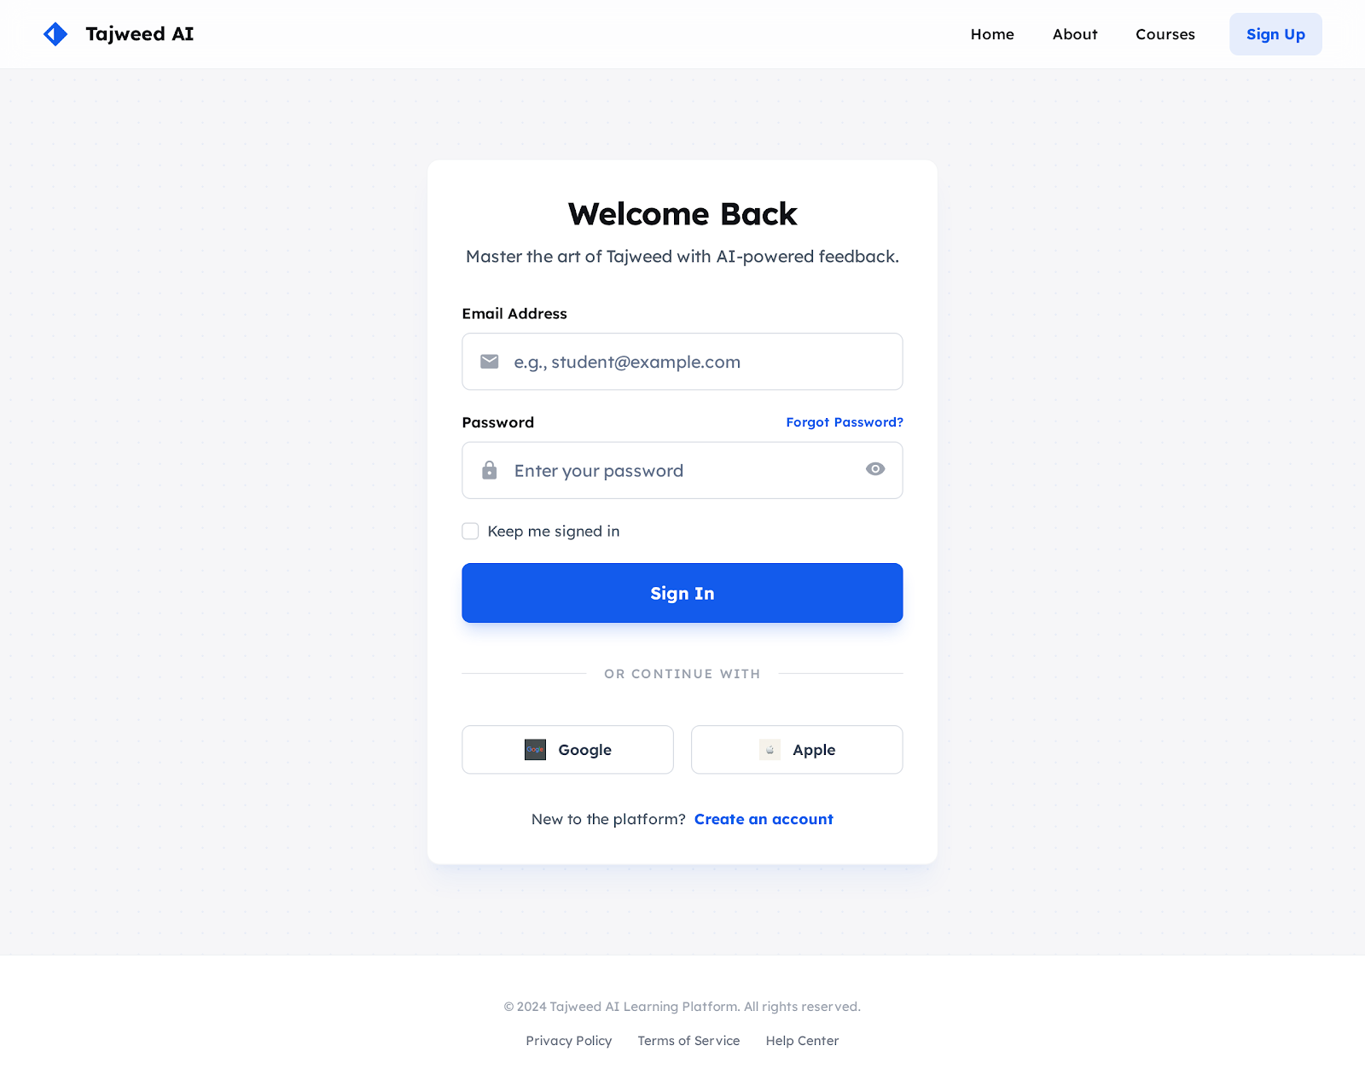

Lesson Page
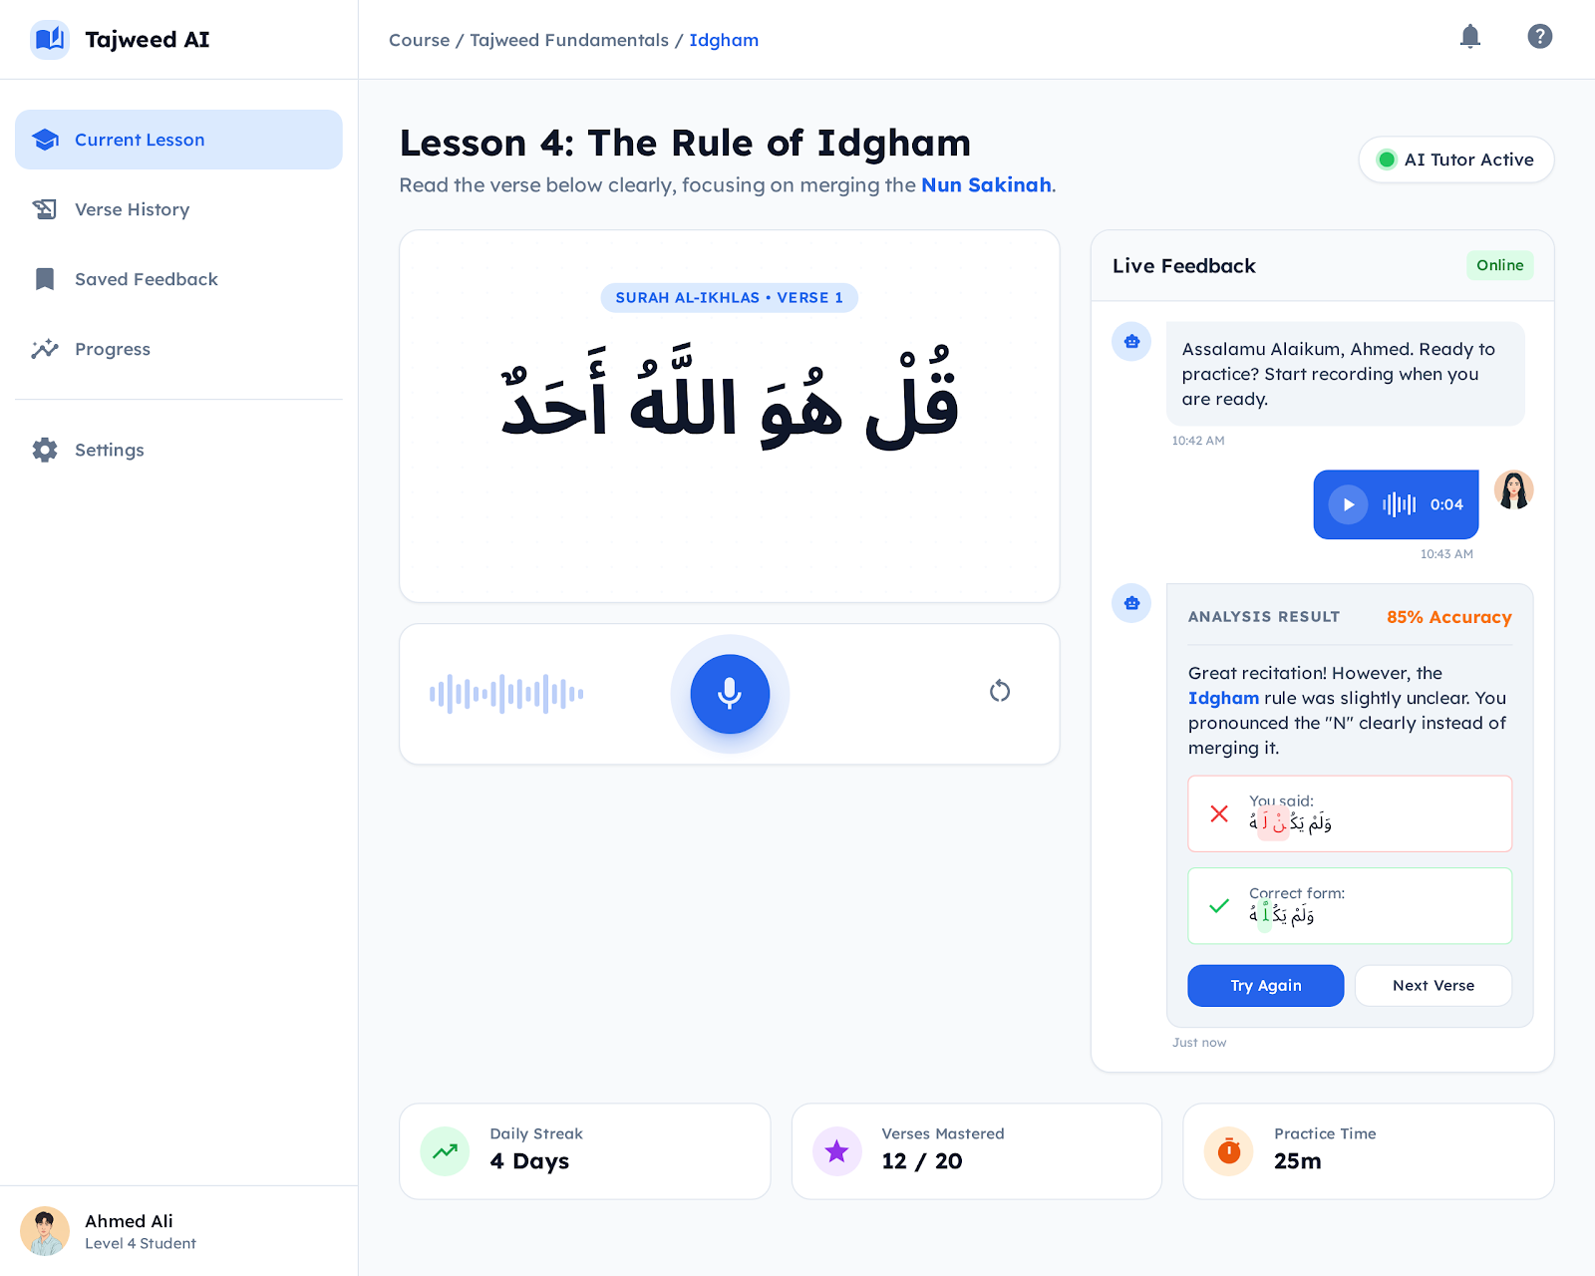

Admin panel


6. REQUIREMENTS MATRIX
A Requirements Matrix is a document that demonstrates the relationship between system requirements and other project artifacts. It is used to verify that all requirements are fulfilled and typically includes the requirement, associated tests, results, and any issues.
For this project:
The SRS (Software Requirements Specification) defines the purpose, scope, and overall requirements of the AI-Based Tajweed Learning Website.
The Requirements Matrix collects and organizes all system requirements, both functional and non-functional, for the web application.
The project uses the following technologies:
Frontend: React.js for building a responsive and interactive user interface
Backend: Node.js with Express.js for server-side programming and application logic
Database: MongoDB for creating, storing, and managing application data

7. APPENDICES
This section is optional. Appendices may be included, either directly or by reference, to provide supporting details that could aid in the understanding of the Software Design Document.

